Tri Pham - 8060220

Professor Hamilton, D.

PROG8150 – User Interface Design Principles

08 Feb 2018

Assignment #1 - Design and implement a novel desktop user interface to launch applications for PC operating systems Windows 8 and Windows 10.

1. **8 principles of user interface design**
2. Know your user

Applications are grouped so that they will be learned faster and recalled better

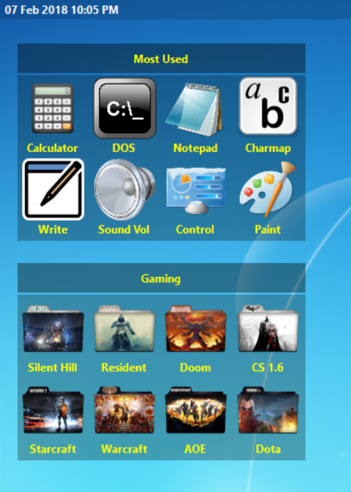

1. Make affordances

The desktop shows strong clues to the operations of things. User can immediately see that the groups can be draggable or the icons in the bottom bar can be clickable

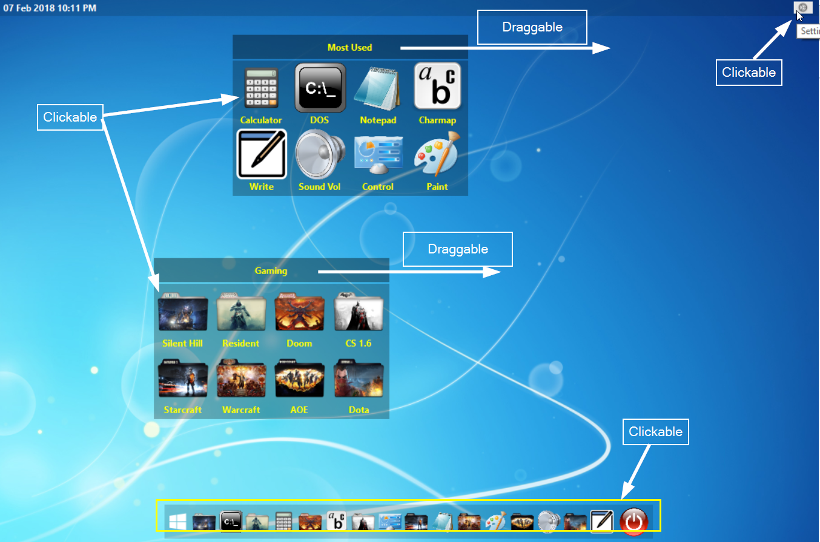

1. Map Functionality

The relationship between controls and their actions. For example: when user clicks on the theme in the setting form, the desktop background is changed immediately.

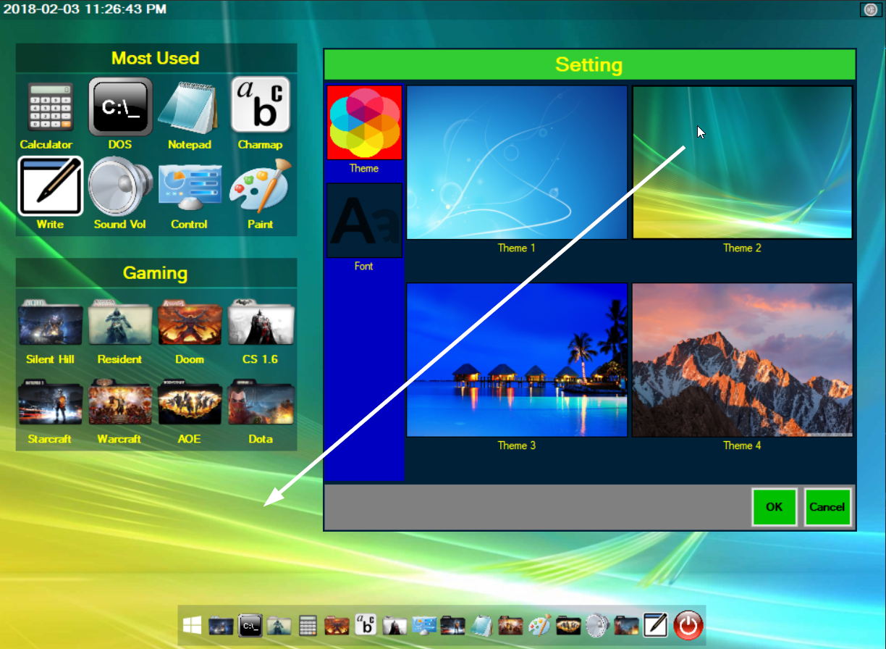

1. Feedback

The system should always keep users informed about what is going on.

For example, when hovering mouse on an icon, its back-color is changed immediately.

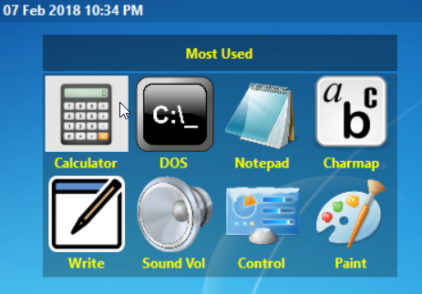

Another example is when hovering mouse on an icon, a tooltip appears

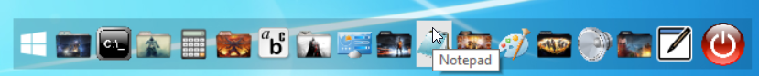

1. Use Metaphors

Using the user’s prior knowledge to make the interface easier

to understand and more enjoyable. For example: icons mapping something useful for the

user. Sound, calculator, window, program etc.

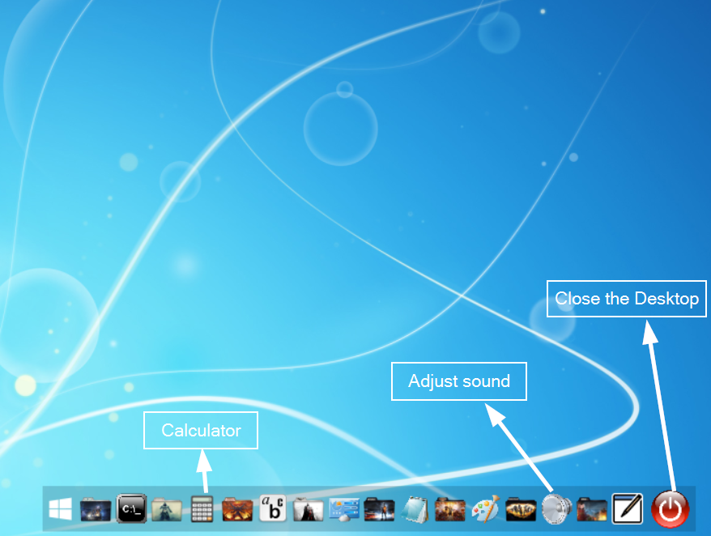

1. Forcing Functions

When the Setting form is opened, icons in the [Most Used] or [Gaming] group are grey out, showing that they are no longer available, preventing user from causing errors.

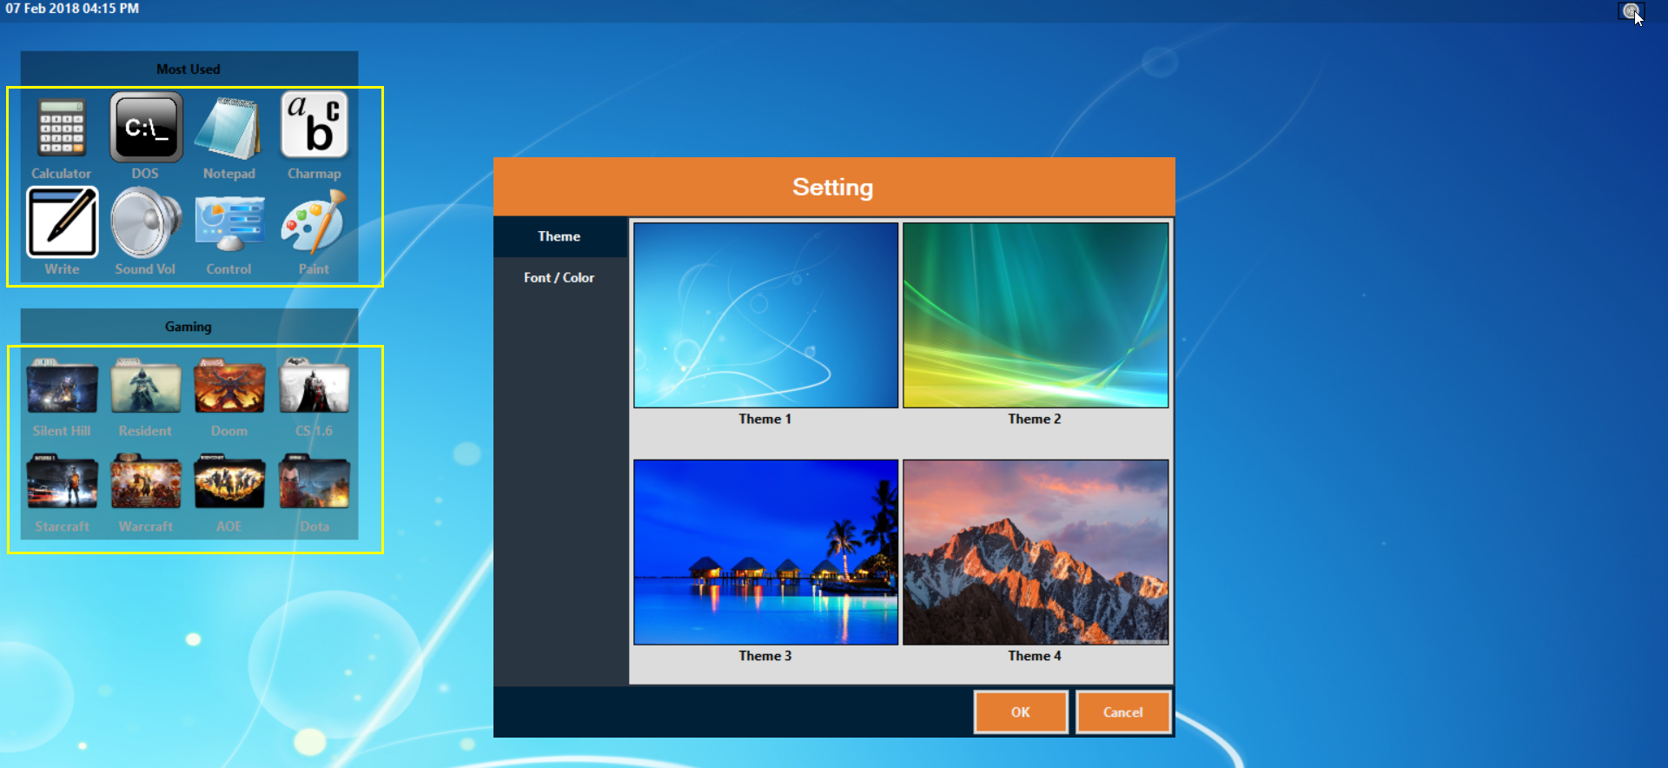

1. Automatic Learning

Offers consistencies that help user acquire interface skills

For example: For icons in the bottom bar and in the start menu, user just needs a single-click to launch an application.

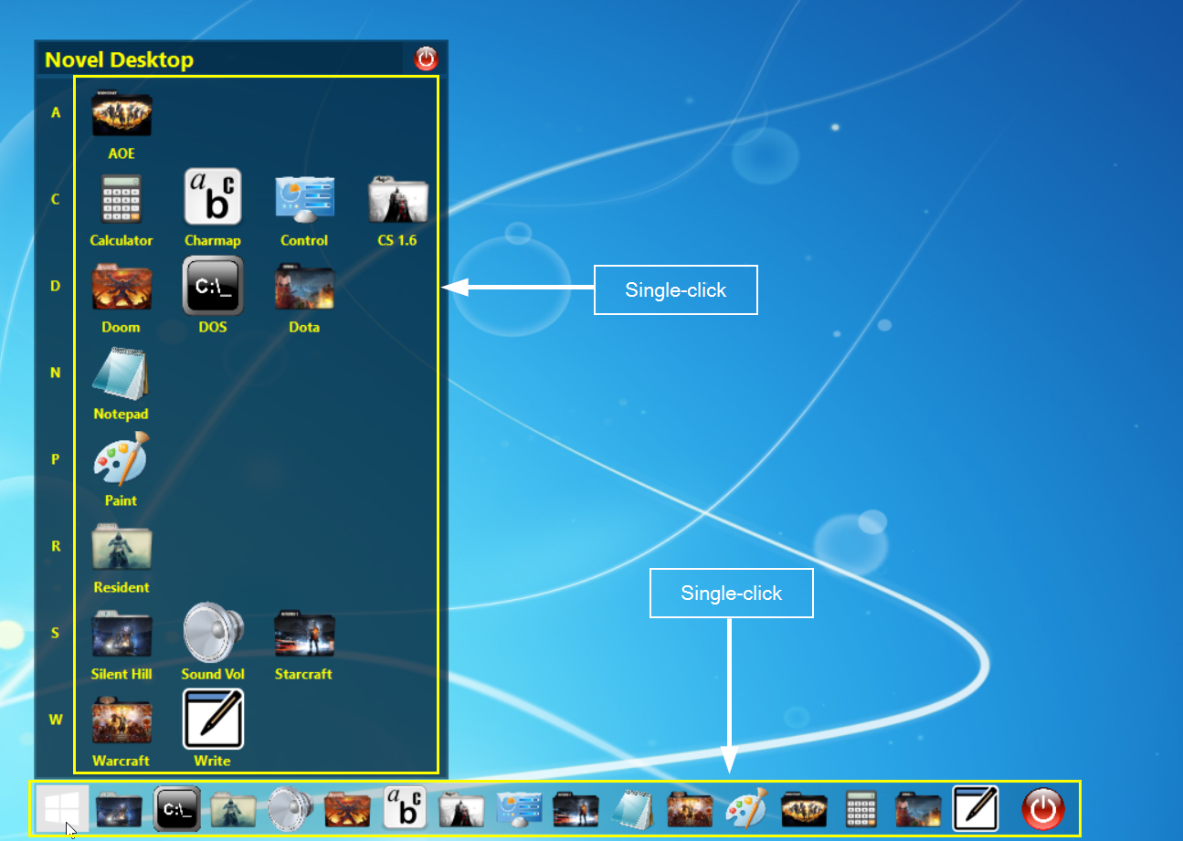

1. Context + Detail

Give the user the detail needed to complete a task, but keep him aware of where he is situated in the bigger picture.

For example: After the Notepad application is launched, there is a black square boxing around the Notepad icon, indicating that Notepad is launched.

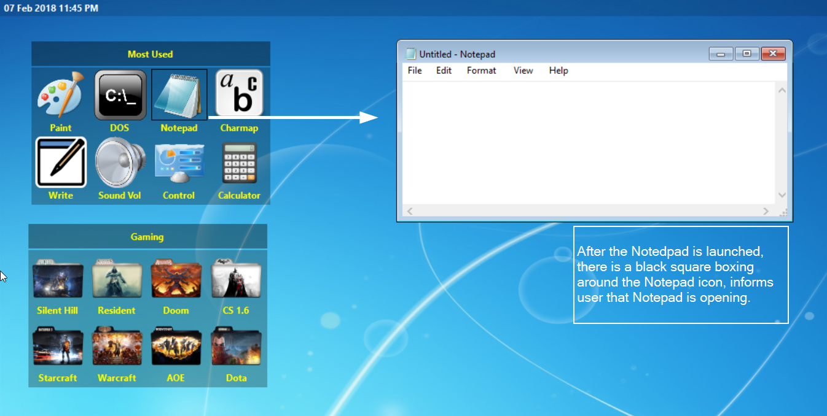

1. **Constrained user interface design using UI design guidelines with supporting** **documentation**
2. Guideline 1 – Confirmations

A confirmation is a modal dialog box that asks if the user wants to proceed with an action.

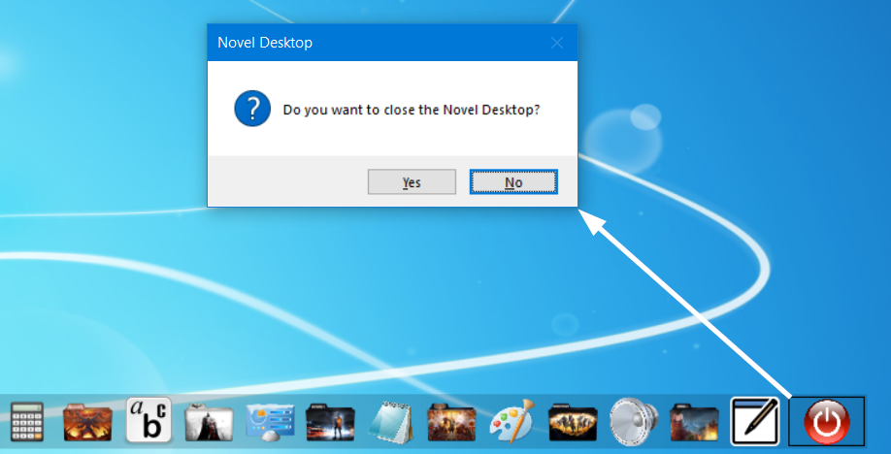

1. Guideline 2: Mouse click

Opening a shortcut on the Novel desktop uses double-clicking.

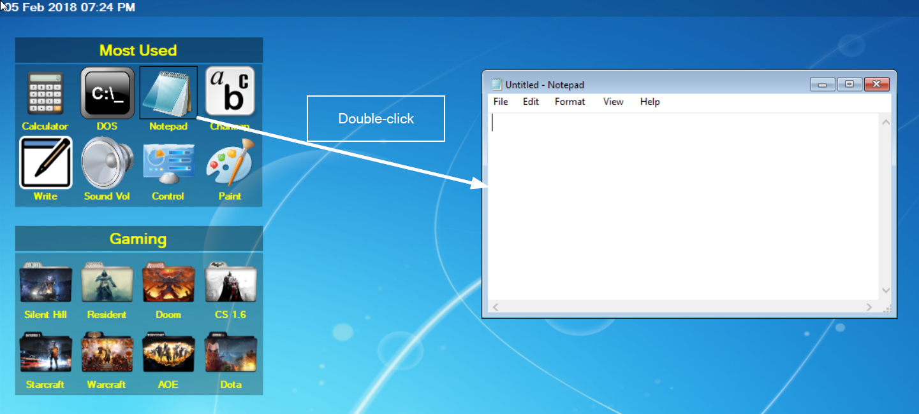

Open an application uses single-clicking.

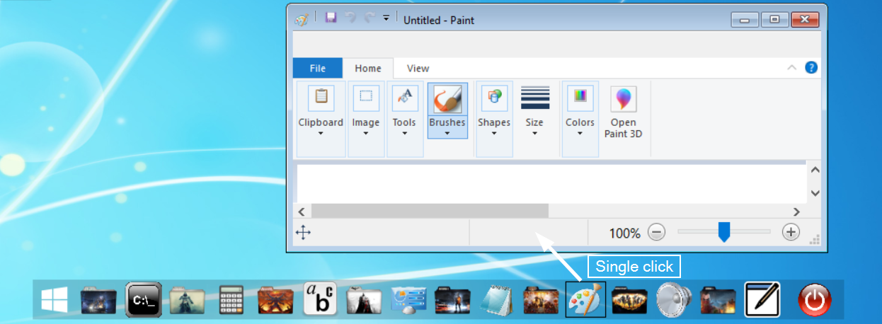

Right click on desktop to refresh screen (to move 2 groups to their old positions)

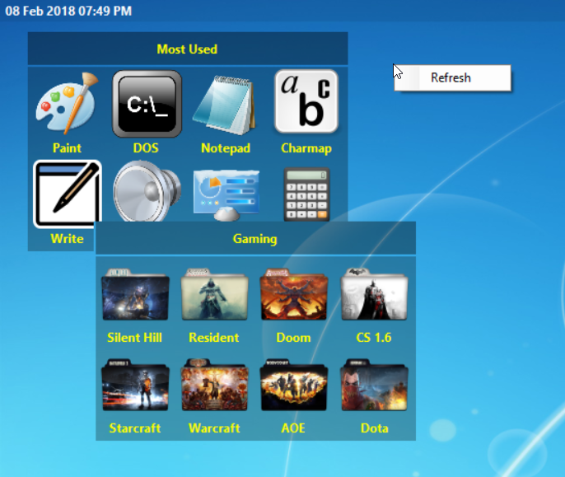

1. Mouse hover: Use alternative (alt) text info tips to describe graphics.

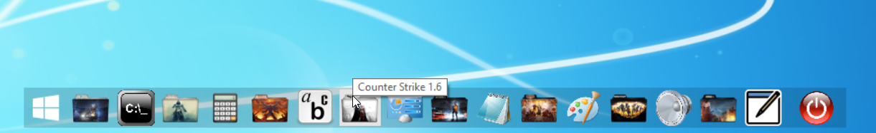

1. Use progressive disclosure to hide complexity.

When user clicks the Start button, all the apps are showed in alphabetical order.

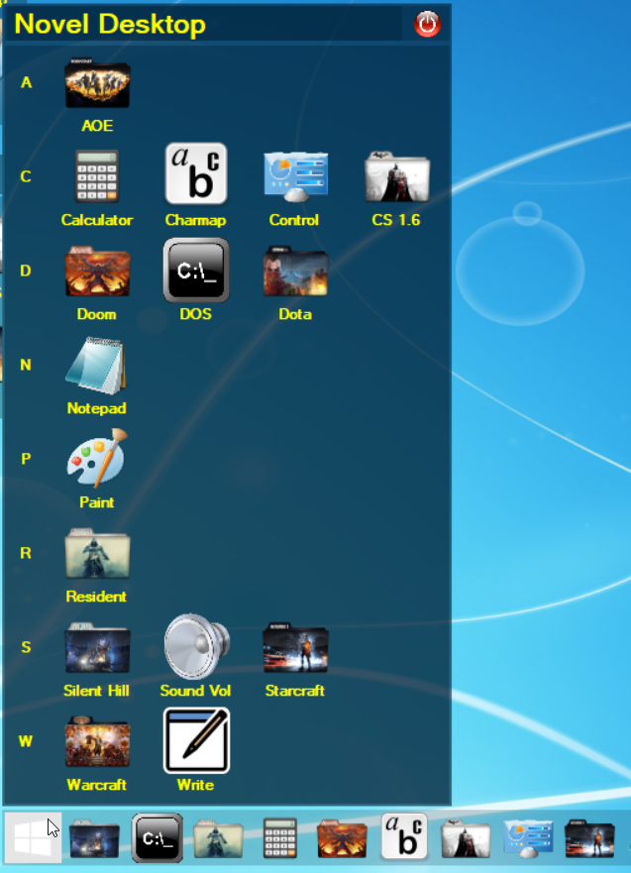

When user clicks the Setting button (at the top-right corner), a Setting form appears

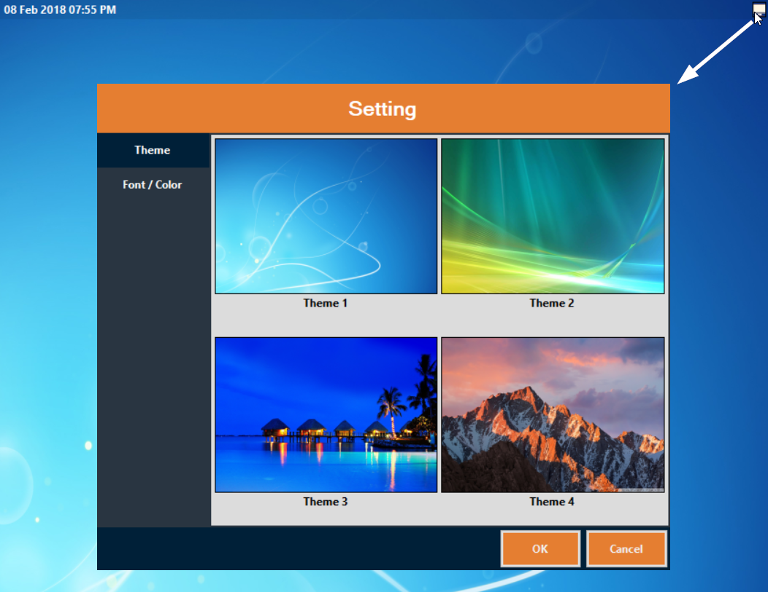

1. Common Dialogs

Font displays the fonts and point sizes of the available installed fonts.

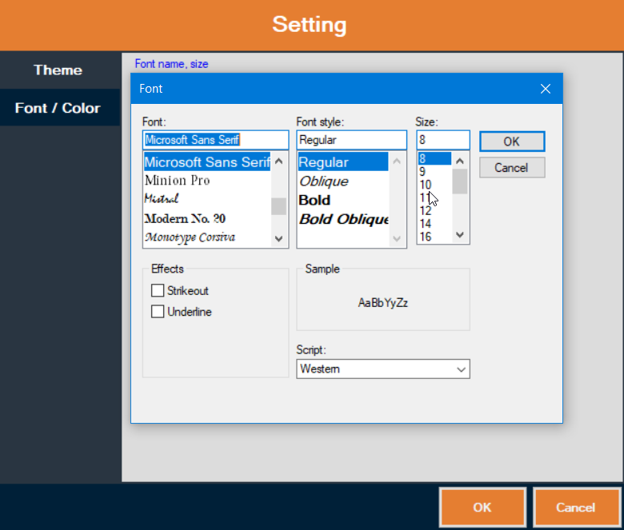

1. Grouping

Groups make a layout appear simpler and easier to parse.

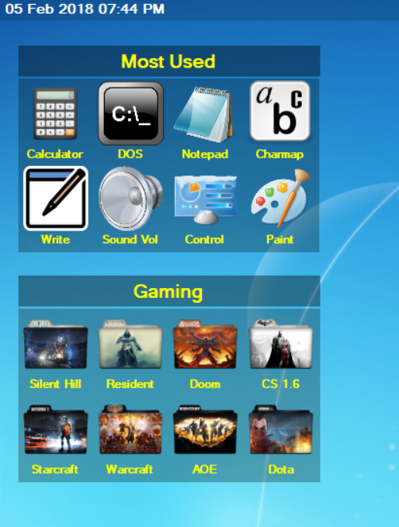

1. Font

Segoe UI is the Windows font intended for user interface text strings.

Text is formatted as Segoe UI.

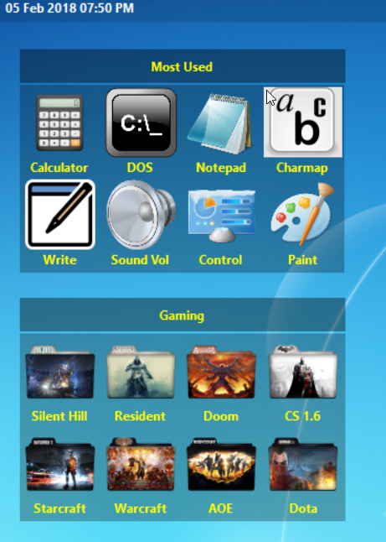

1. Graphic Elements

Use Backgrounds to emphasize or de-emphasize different types of content.

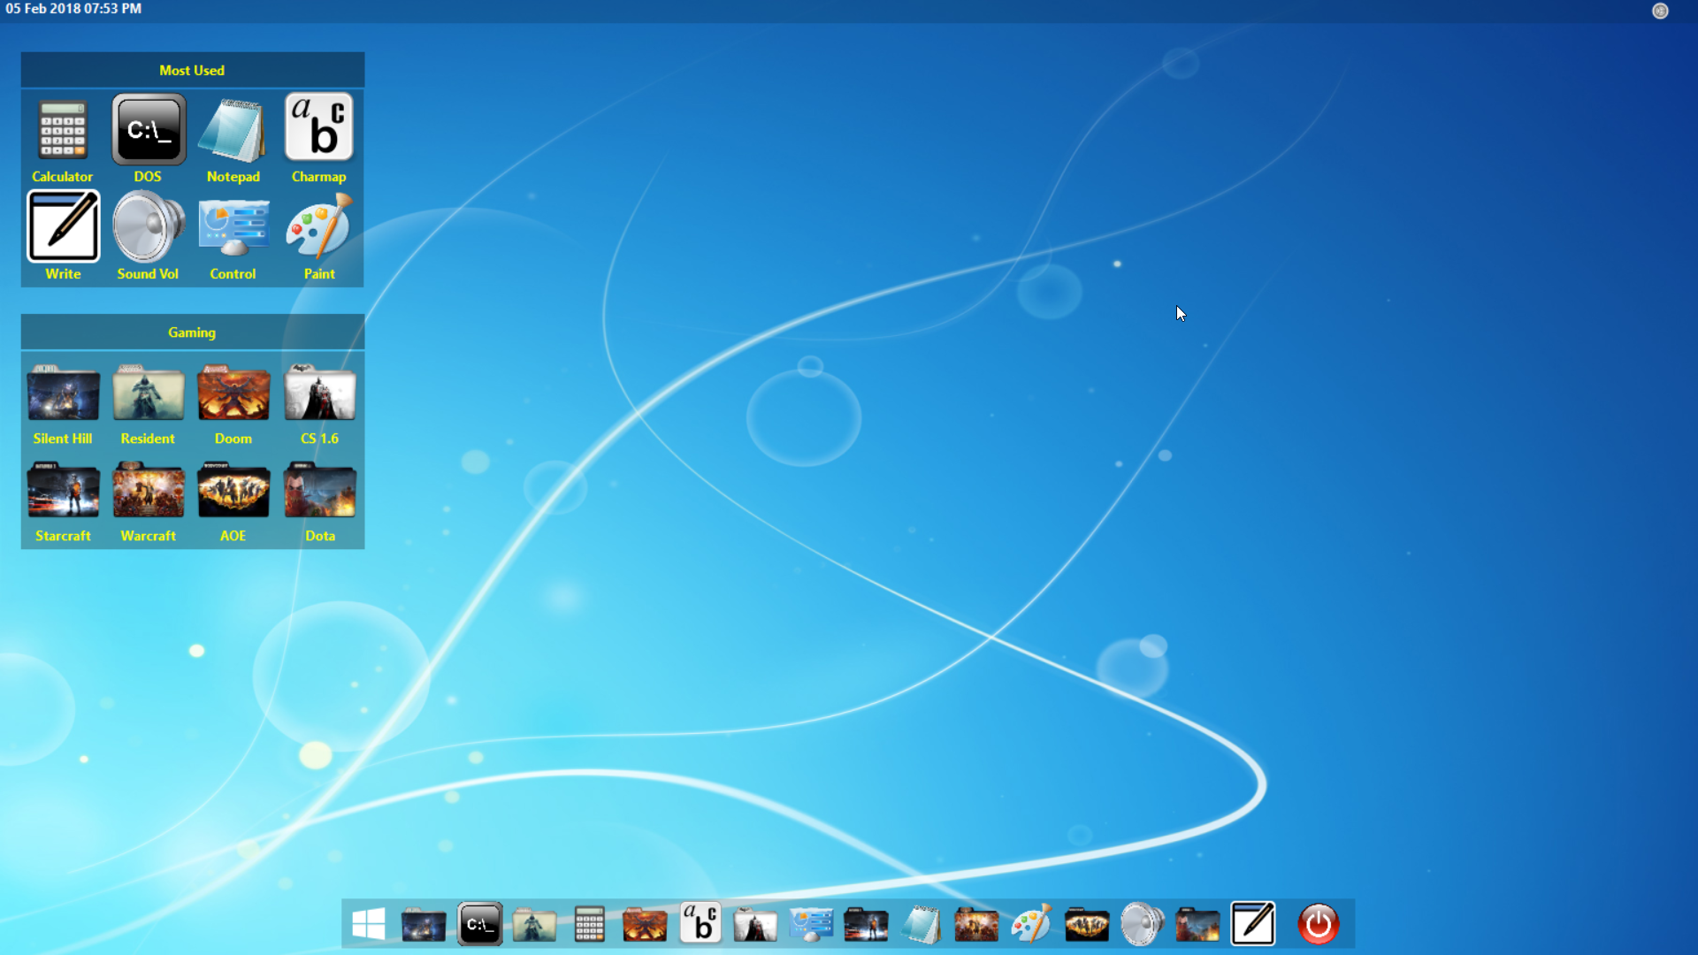

1. Taskbar

The taskbar is the access point for programs displayed on the desktop.

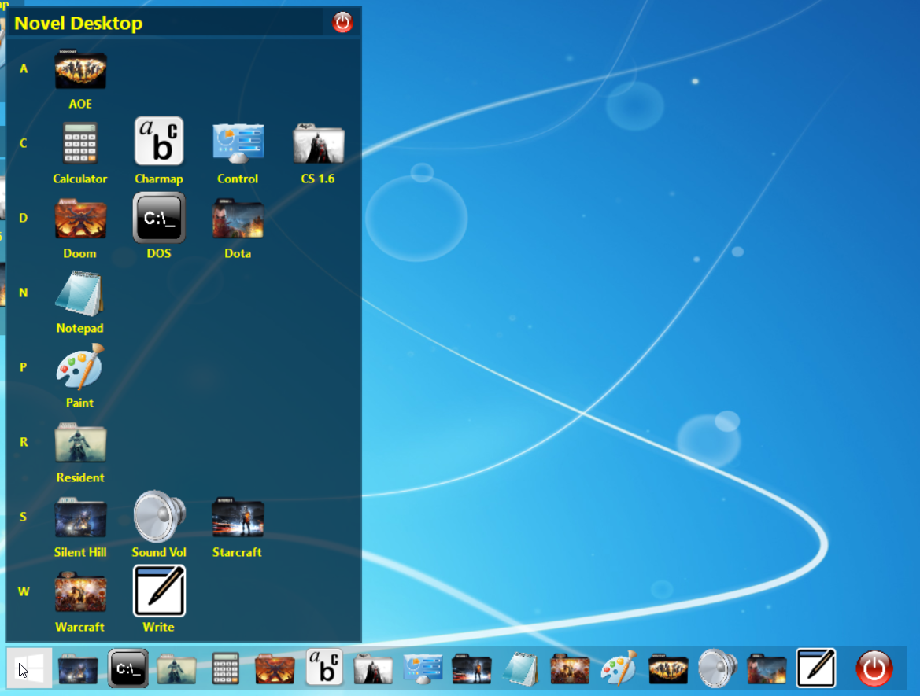

1. Notification Area

Provide only one notification area icon per component.

Use an icon with 16x16, 20x20, and 24x24 pixel versions.

